Pre-Reflection:

Unveiling a Realm of New Possibilities

Simon Duchaine Morneau 40319302

Concordia University

CART-253 B 2242 (Fall 2024)

Dr. Pippin Bar

September 17, 2024

To begin with, I don’t have any programming experience whatsoever. But, as of now, I’ve been impressed with how simple it is to draw shapes and create programs in JavaScript. I’ve never truly understood how programming worked before, and now that I’ve seen how straightforward it is, a realm of new possibilities just unveiled itself. Every time we learn more theory in class, more creative possibilities reveal themselves, and it's fascinating. From a creative standpoint, it is very liberating to realize that we can write whatever program we want and that the computer, if the program is written correctly, will process it and play it instantly. I am far from having the skills to do it yet, but I already have a bunch of ideas I could implement for future video games I’ll develop.

First of all, I find it impressive how programming can be implemented into many different projects and artworks. What especially surprises me is how a program can transmit a clear message to the viewer and make him feel emotion for a machine. For example, let’s talk about the artwork “Can’t Help Myself”1 by Sun Yuan and Peng Yu. In brief, that artwork consists of a robotic arm carrying a squeegee that is surrounded by a red liquid reminiscent of blood. The robot is sitting on a slightly elevated floor, which makes the liquid drip away from the robot, But since the program of the robot orders it to keep its blood as close as possible, the machine repeatedly tries to shovel back the liquid closer every time it flows away. This program creates an artwork representing a being who is on an infinite quest to bring back his blood that keeps flowing away from it. It makes you feel pity for the robotic arm, which is stuck in a worthless infinite loop, trying to achieve an unachievable goal. I think this artwork perfectly demonstrates how even the simplest program (if used effectively) can transmit a powerful message to the viewer.

Secondly, another programming prowess, in my opinion, is the game *Hollow Knight* 2. The simplicity of the designs and the effectiveness of the actions are remarkable. The actions are programmed in a way that makes them useful in a variety of different ways against a variety of unique enemies. It impresses me because, as a young artist, I find that the most difficult thing to do is simplify something complex. In art, in design and especially in programming. But that is what Hollow Knight does perfectly. The main character’s and the enemies’ designs are simple and easily recognizable. The backgrounds are simple enough not to be too distracting, and the gameplay (the programming) has a few simple attacks that can be used in a bunch of different situations, making the gameplay experience entertaining and enjoyable.

Thirdly, another project that I find very inspiring is a video game called *Journey* 3. It is a beautiful game that made the sacrifice of having simple gameplay to amplify the majesty of its world and story. First of all, the game’s visuals are breathtaking. Not because they are complex and realistic but actually the contrary, because they are very simple and unique. In addition, the way they are displayed and the simple gameplay make us feel like we are entering a vast and beautiful world. I still remember the experience I had when playing that game because that is what the developers focused on. For example, there was a beautiful scene where the character surfed on a dune while watching the landscape. And even if the gameplay (programming) was simple and almost insignificant, the visuals and the music were so captivating that I just stayed in awe, fully experiencing the majesty of the game. But if that level had instead a challenging gameplay, we would not have had the time to admire the world the developers created and its majestic ambiance. Looking back at that fond memory, I think there is something very important to learn from that game: that sometimes, less is more. Yes, we can add a bunch of obstacles and make the game difficult, but if we intend for the gamer to have a memorable and peaceful experience, it is better to focus on the ambiance rather than the difficulty of the gameplay (and the complexity of the program).

Lastly, my dream project is inspired by a project I saw a few years ago. The project I am referring to is essentially a portfolio. But the portfolio, at first view, is a simple game. Effectively, to show his programming skills, Bruno Simon made a small driving game where you control a truck and drive through all of his past projects4. I think that it is a very lovely, feasible idea that can make a portfolio stand out. So, my dream project would be to recreate a version of this project, probably with a different concept but with the same premise. Essentially, I would like to create an innocent game that acts as a portfolio to display all of my past projects (in other words, my illustrator’s skills) as well as my programming skills.

Works Cited

1. <https://www.guggenheim.org/artwork/34812>

2.

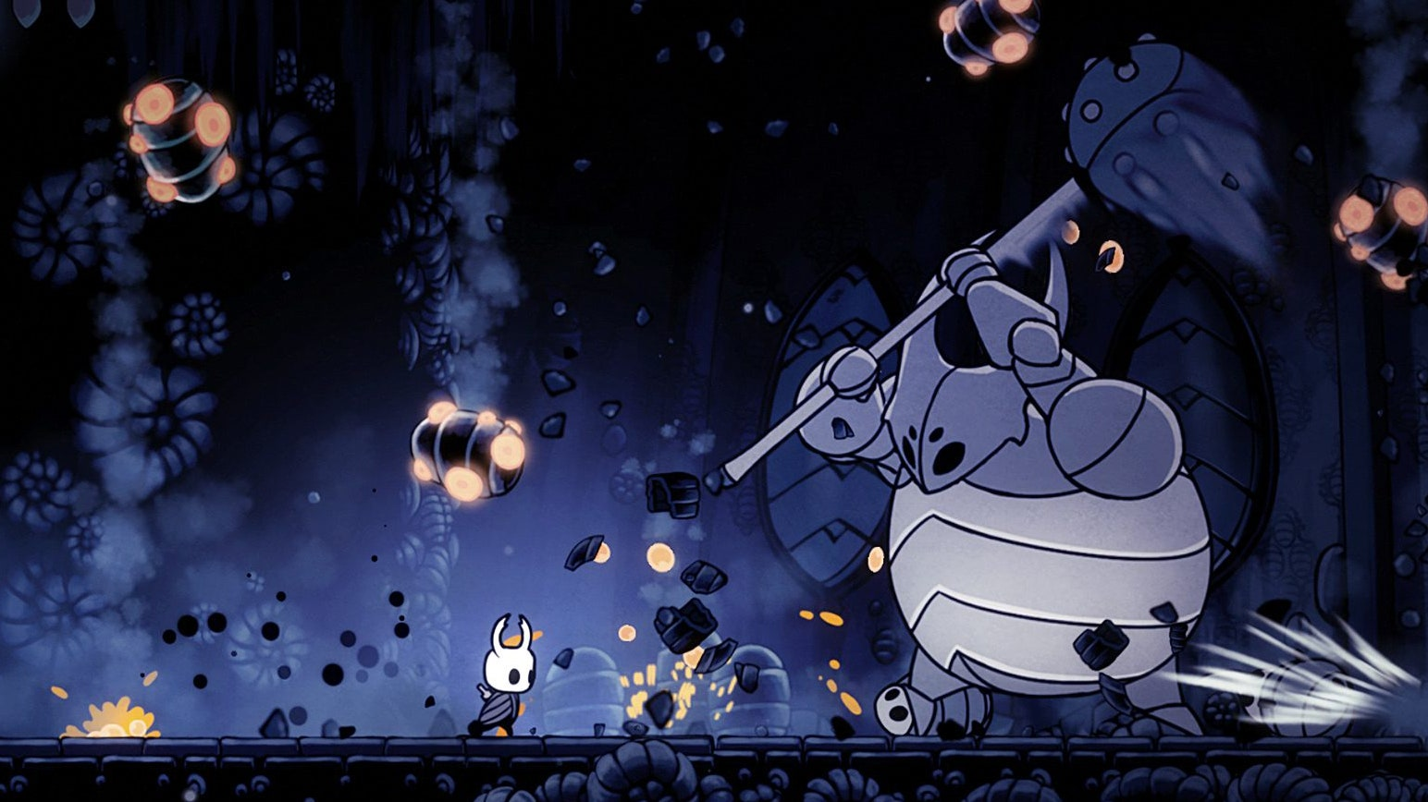

3.

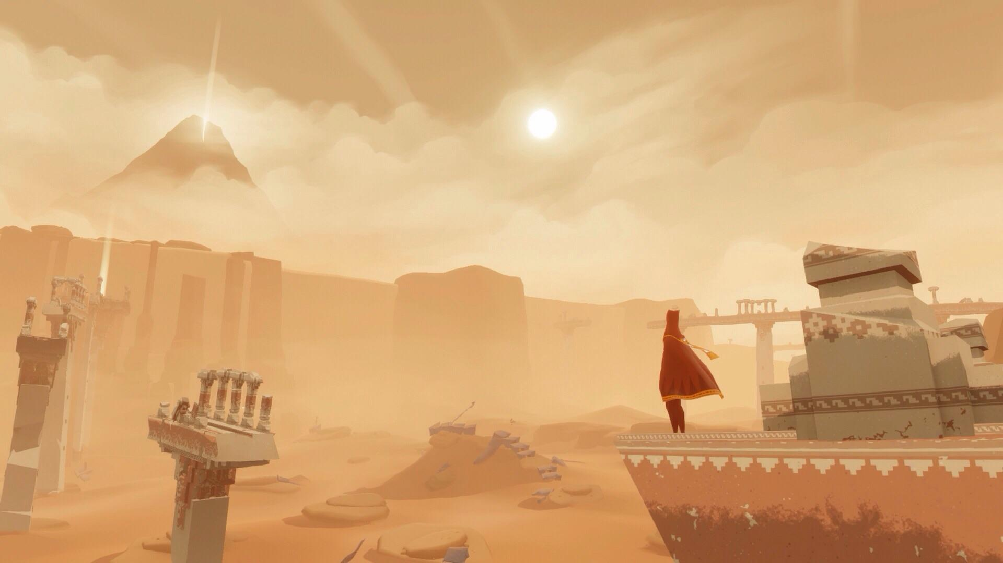

4.  <https://bruno-simon.com>